# The explanation of UR_Kinematics package

# 1 [Task Summary]

There is a ur_kinematics package created specifically for UR series robot to solve the kinematics problem. The ur_kinematics package encapsulates a moveit_plugin so we can easily choose and use it through the moveit_setup_assistant. Here we are going to explain the package as much as I can.

# 2 [Process]

**Step 1:** Let us take a look at the files in this package.



Through the cd command, we will see 3 .cpp files in the src folder.

**ur_kin.cpp** contains the definition of inverse/forward kinematics.

**ur_kin_py.cpp** encapsulates the c++ function and turn it into a python interface.

**ur_moveit_plugin.cpp** encapsulates the inverse/forward function we created in ur_kin.cpp and turn it into a moveit_plugin so we can easily choose it in moveit_setup_assistant.

**Step 2:** ur_kin.cpp and ur_kin.h.

We use IDE to open the ur_kin.h in the **include** sub_directory.

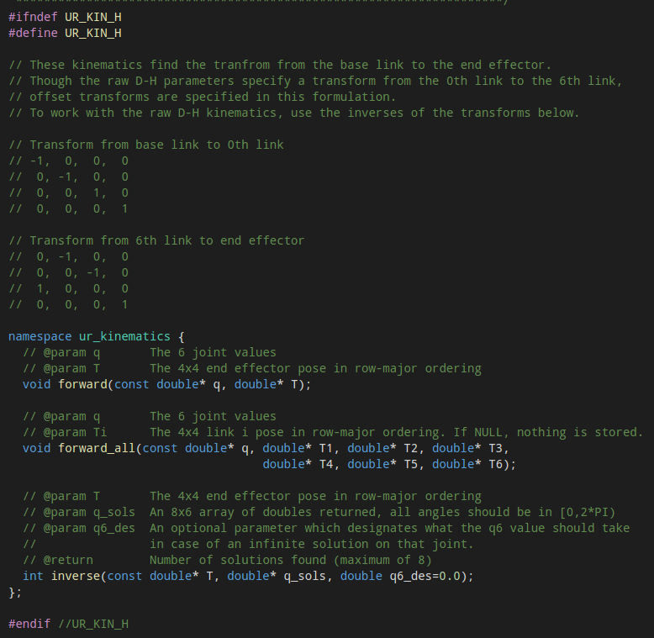

Here we can explicitly see all the function’s definition and parameters type.

**Step 3:** ur_kin_py.cpp

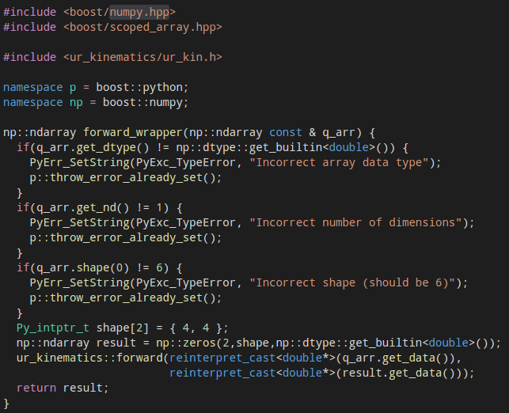

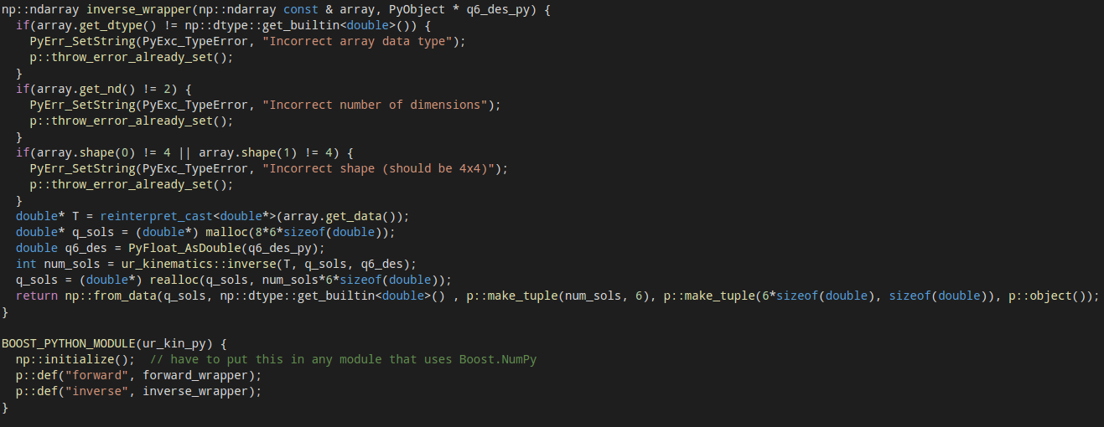

**Step 4:** ur_moveit_plugin.cpp

There are too many functions to talk about in this file. I only pick the most important part up -- the method that picks up the best solution.

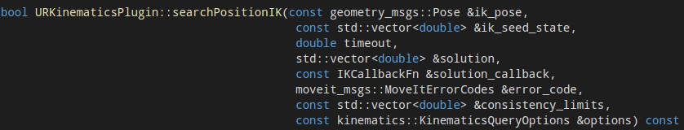

This method is contained in searchPostionIK() function.

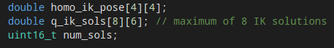

We create a homogeneous pose and put it in the 4*4 array. Then we create a q_ik_sols[8][6] to contain the 8 solutions of inverse kinematics.

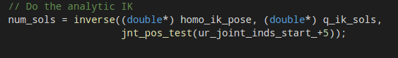

Do the analytic IK.

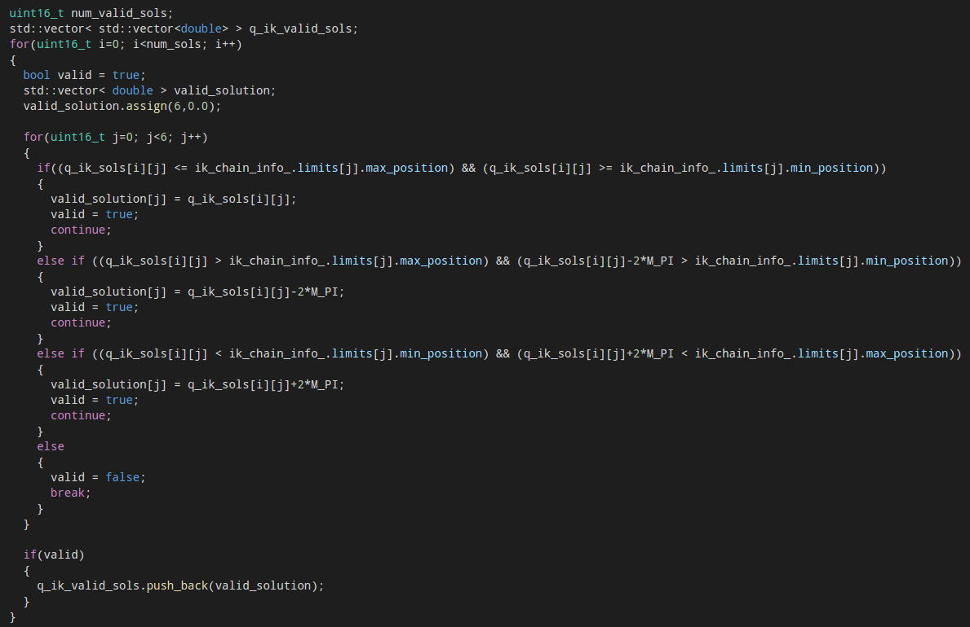

Verify if each solution is valid.

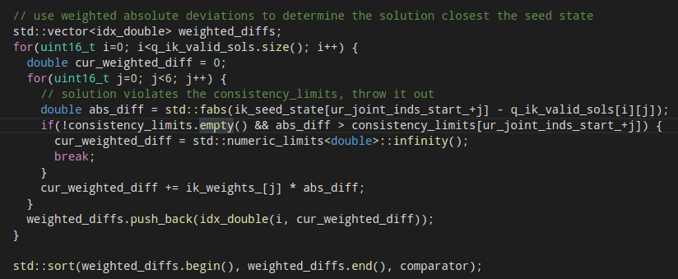

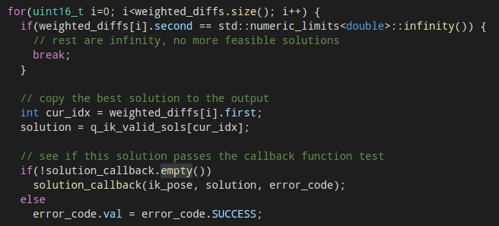

Choose the best solution closet to the current state.

**Step 5:** Chooseur_moveit_plugin in moveit_setup_assistant

